**RV College of Engineering**

**Experiential Learning Report**

**Project-Based Learning**

**2024-25**



**Fast Food Monitoring Using AR and Digital Twin**

**Student(s)**

| **USN** | **Name** |
| --- | --- |
| **1RV24ME038** | **G.D.Pranav.L** |
| **1RV24CS027** | **Akshay Avinash** |
| **1RV24IS130** | **Sumukha Upadhyaya** |
| **1RV24CS006** | **Aarti Shirvante Pai** |

**Mentor**

| **Name, Designation & Department** |
| --- |
| **Dr.Nivya Muchikel,Assistant professor, Mathematics Department** |

1. **Introduction**

Our project aims to integrate Augmented Reality (AR) and Digital Twin (DT) technologies to create an immersive, interactive model of food manufacturing operations. It provides a real-time virtual replica of the physical plant, allowing users to monitor supply chain data, visualize processes, remotely control equipment like valves via touch or voice commands, and identify operational issues through data analysis.

This can be further extended to other industries as well with minimal efforts.

1. **Problem Definition**

**Problem Statement:**  
AR-enabled monitoring system with an AI voice assistant to enhance real-time decision-making and operational efficiency in industrial supply chains.

**Problem Context:**Manufacturing industries have long faced challenges stemming from slow, manual monitoring and control processes. These traditional methods often require on-site personnel to physically inspect equipment, record data by hand, and manually operate control mechanisms such as valves and switches. This approach not only consumes significant time and labor resources but also increases the risk of human error, which can lead to production inefficiencies, unplanned downtime, and costly mistakes. Moreover, manual processes can delay the identification and resolution of critical issues, potentially compromising product quality and safety, and making it difficult to maintain compliance with stringent industry regulations.

The integration of AR digital twin solutions is transforming the way manufacturers monitor and control their operations. By providing real-time visibility into every aspect of the production process, these technologies enable remote monitoring, instant data access, and intuitive control interfaces. Operators can visualize equipment status, receive alerts about anomalies, and even control machinery—such as opening or closing valves—through interactive AR displays or voice commands. This not only streamlines workflows and reduces response times but also enhances safety, reliability, and overall productivity. As a result, manufacturing facilities can minimize downtime, improve decision-making, and achieve higher levels of operational excellence.

1. **Objectives**

**Main Objective:**Our integrated solution for the food manufacturing industry combines advanced web-based monitoring, intelligent voice control, immersive AR visualization, and tangible 3D modeling to deliver a comprehensive platform for optimizing supply chain operations. The system features a robust website that provides real-time access to sensor data from across the production environment, allowing for instant detection and response to any anomalies. Seamlessly connected to this platform is a voice assistant, which enables users to control supply chain processes and execute commands through natural speech, enhancing both efficiency and safety. Additionally, a dedicated mobile application leverages AR and digital twin technology, giving users an interactive, real-time view of the facility and its operations. To further support understanding and demonstration, a 3D printed model of the facility is integrated, offering a physical representation that works in tandem with live sensor data and digital visualization.

**Specific Objectives:**

1. **Real-Time Remote Monitoring**:Enable continuous, remote monitoring of critical supply chain parameters by integrating IoT sensors throughout the manufacturing environment, ensuring instant detection and response to anomalies.
2. **Hands-Free Process Control**:Provide intuitive, voice-activated control of manufacturing processes through a smart assistant that seamlessly interacts with both web and mobile platforms, enhancing operational efficiency and safety.
3. **Immersive Visualization and Decision Support**:Implement AR and digital twin technologies to deliver interactive, real-time visualizations of the facility, improving situational awareness and supporting data-driven decision-making for operators and managers.
4. **Tangible Demonstration and Stakeholder Engagement:** Utilize a 3D printed model of the facility for live demonstrations, stakeholder engagement, and educational purposes, effectively bridging the gap between digital insights and physical process understanding.

**Expected Contributions to the Field:**

1. **Advancement of AR/Digital Twin Technology**: Our project is expected to make significant contributions to the field by advancing the application of AR/VR digital twin technology within manufacturing systems. By integrating real-time monitoring, remote control, and automated fault detection across the entire supply chain, the solution addresses critical industry challenges related to efficiency, transparency, and responsiveness. This comprehensive approach not only enhances process visibility but also supports predictive maintenance and rapid decision-making, setting a new benchmark for smart manufacturing environments.
2. **Pioneering Intuitive User Interfaces**: In addition to technological advancements, the project will pioneer the use of intuitive touch and voice interfaces for supply chain control. By enabling operators to interact with complex manufacturing systems through simple, user-friendly commands—either via touchscreens or natural speech—the platform significantly improves user experience and operational efficiency. This innovation is expected to lower the barrier to adoption for advanced digital technologies in manufacturing, making sophisticated process control accessible to a broader range of users and ultimately driving greater productivity and safety across the industry.

In summary, our project will set new standards for smart manufacturing by seamlessly integrating AR digital twin technology with real-time monitoring and control. The introduction of intuitive touch and voice interfaces will make advanced supply chain management more accessible and efficient. These innovations are poised to enhance productivity, safety, and user engagement across the manufacturing sector.

1. **Methodology**

The project employed a phased deployment strategy to integrate a cutting-edge AR-enabled digital twin system within a food manufacturing environment. The key methodological components included:

## **1. Data Collection and Monitoring:**

* IoT Sensors: Installed temperature, humidity, and flow sensors at key points in the supply chain to gather real-time operational data.
* Centralized Data Platform: All sensor data was streamed to a central system for live monitoring and analysis.

## **2. Valve Control and User Interaction**

* Manual and Remote Valve Operation: Enabled users to open and close valves directly through a tablet’s touch interface, with real-time feedback on valve status.
* Real-Time Visualization: Used AR/VR on tablets to visually represent the current state of valves and highlight any operational changes instantly.

## **3. Problem Detection**

* Automated Alerts: The system analyzed incoming data to detect anomalies or issues, automatically flagging problem areas within the AR interface for immediate attention.

**4. Voice Agent Integration**

* Voice Control: Integrated a voice assistant that allows users to control valves and issue commands using natural speech, supporting hands-free operation even in noisy environments.

### **Phase 1: Conceptualization and Research (Week 1–2)**

1. **Define the Problem:**
   * Inefficient Manual Monitoring and Control: Traditional manufacturing processes rely heavily on manual inspection and control, leading to slow response times, increased human errors, and operational inefficiencies.
   * Lack of Real-Time Visibility and Remote Access: Existing systems often lack comprehensive real-time data visualization and remote control capabilities, limiting proactive fault detection and timely decision-making across the supply chain.  
     **Milestone:** Clear problem statement and conceptual design.
2. **Literature Review:**
   * Study existing research on AR, Digital Twin systems, and their integration.
   * Review multiple industries for specific applications  
     **Milestone:** Theoretical framework and methodology selection.

### **Phase 2: System Design and Prototype Development (Week 3–5)**

1. **Design the 3D model for food industries**
   * Have valves and a rotor spinning for proper mixing for condiments.
   * Define hardware requirements: sensors (temperature, pH, etc), raspberry pi, valves.
2. **Build the Prototype:**
   * Assemble the 3D model and start progress on the AR app along with a website for displaying sensor values.
   * Install sensors to collect real-time data for temperature and pH. Install valves in 3D model for seamless control  
     **Milestone:** 3D model and base website were created

### **Phase 3: Sensor connections and Database Creation(Week 6–8)**

1. **Database Creation:**
   * Created a database using mongoDB and necessary collections were added.
2. **Sensor Connections:**
   * Different sensors and boards were inspected, and raspberry pi was finalized on.

**Milestone:** Database was created for ease of backend, and sensors were connected in the hardware side.

### **Phase 4: Valve and Rotor Mechanism (Week 9–10)**

1. **Valves and Rotor functionality:**
   * Create a valve structure where the user can control the functions of it.
   * Rotor speed controlled by the user. The blades of the rotor were 3D printed and fitted.  
     **Milestone:**

### **Phase 5: Website Development and System Integration (Week 11–12)**

1. **Develop Website for Monitoring:**
   * Design a user-friendly interface to display real-time data, including temperature, pH, humidity, etc.
   * Use a database (mongoDB) to store and retrieve historical data for analysis.
2. **System Integration and Testing:**
   * Connect the 3D model, database, AR app and website into a unified platform.

**Milestone:** Fully functional and integrated system.

### **Phase 6: Deployment and Analysis (Week 13–14)**

1. **Deploy System:**
   * Deploy the system in a controlled environment to evaluate its performance.
   * Monitor and analyze the results, including the latency of the model.
2. **Iterate and Improve:**
   * Use insights from testing to try to reduce latency
   * Identify and address any limitations or inefficiencies.  
     **Milestone:** Optimized and ready-for-deployment AR system.

**5.** **Project Execution**

### **Planning and Design Phase**

The planning phase began with brainstorming sessions to address energy loss in PV panels due to waste heat. The team explored integrating Thermoelectric Generators (TEGs) to capture this heat and convert it into additional electricity. Discussions focused on the optimal placement of TEGs, thermal regulation strategies, and integrating machine learning for real-time efficiency monitoring. The team also decided to develop a website for displaying system data.

Key components like TEG modules and suitable PV panels were researched, and design drafts were created for the system’s integration, focusing on maximizing energy recovery while maintaining operational efficiency.

**6.** **Tools and Techniques Used**

**Tools used:**

#### **1. Hardware**

* **Raspberry Pi** (ARM Cortex-A72, 4GB RAM) — edge computing gateways
* **IoT sensors** — various types (temperature, proximity, etc.)
* **Voice modules / microphones** — for voice control input
* **Network equipment** — Wi-Fi 6 routers, Ethernet switches

#### **2.Software and Programming**

* **Unity** — development of AR/VR models, digital twins, 3D visualization
* **JavaScript (JS)** — web integration and interactivity
* **Python** — sensor control logic, data pre-processing, backend scripts
* **MongoDB** — database for storing IoT and AR/VR data
* **Adafruit libraries** — sensor and hardware interfacing with Raspberry Pi
* **Gemini API** (or similar) — generative AI for enhanced user interaction and NLP.

**Hardware Techniques**

1. Raspberry pi: Used to control and process data from sensors and manage system operations.

2. Sensors Integration:

Temperature sensors to measure temperature and humidity

IR sensor to calculate RPM for validation.

3. Motors and Valves: For valve control and rotor speed control

4. 3D Printing: Custom model designed with the stands for extra stability, containers and a rotor.

**Software Techniques**

1. ChatterBox: Used for Text to speech handling.

2. 3js: Used to display a 3D model in the website.

3. Flask Framework: Built the backend to connect the hardware to the web interface.

4. MongoDB: Database management tool used to store parameters of the solution as well as the parameters of the machine.

5. Jinja: Rendered dynamic HTML templates to display live data on the web interface.

6. Google Gemini API: Integrated for the Voice AI for smart command recognition.

7. Unity: Used to build the AR app.

**System Techniques:**

1. AR app for model visualization: Using a QR code, the model can be visualized through the app and the speed of rotor and status of valves can be checked.
2. Data Collection and visualization: Data is collected through sensors which is linked to a raspberry pi and then stored in the Database. The website visualizes data in the form of graphs, etc and displays it by fetching these values.
3. AI Voice Agent: The user can query any questions about the model to the voice agent and get back responses. The user can also change the parameters of the model using the voice model. A text model is available for the same.
4. 3D model connected to raspberry pi: The necessary connections are made to the model and as the user prompts the AI agent to make changes, live changes are demonstrated in the model.

**7.** **Results and Discussion**

**Website Front:**

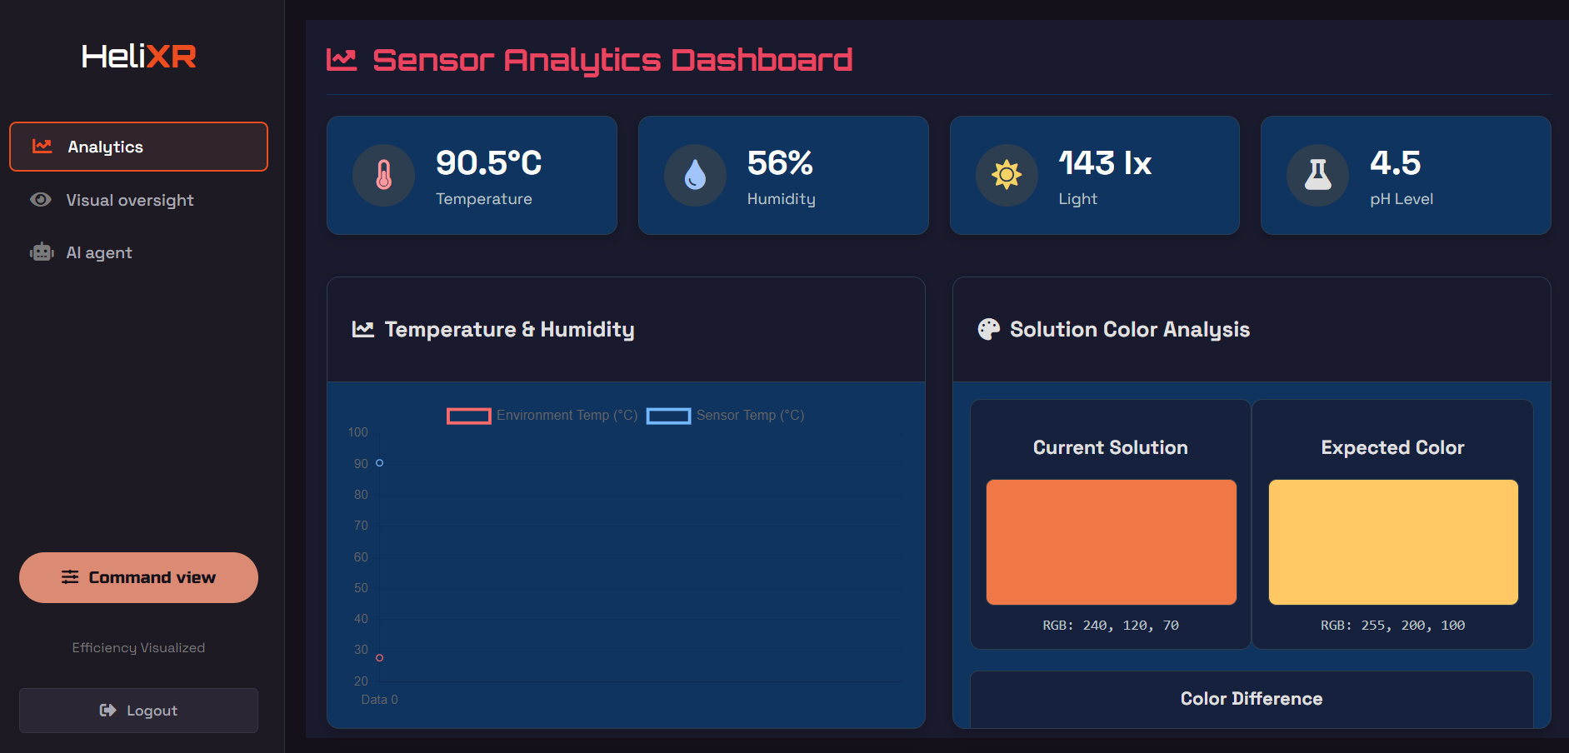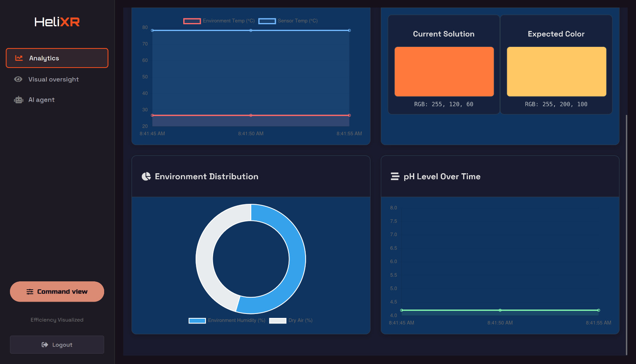

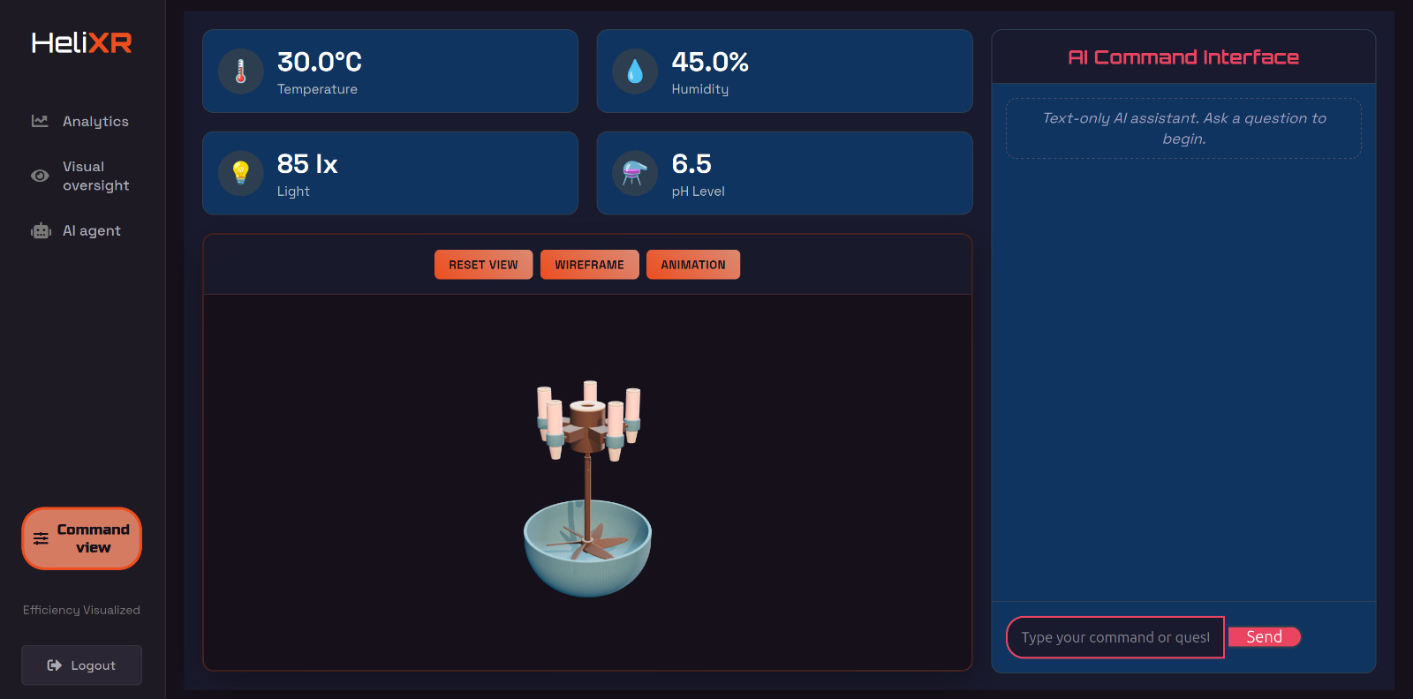

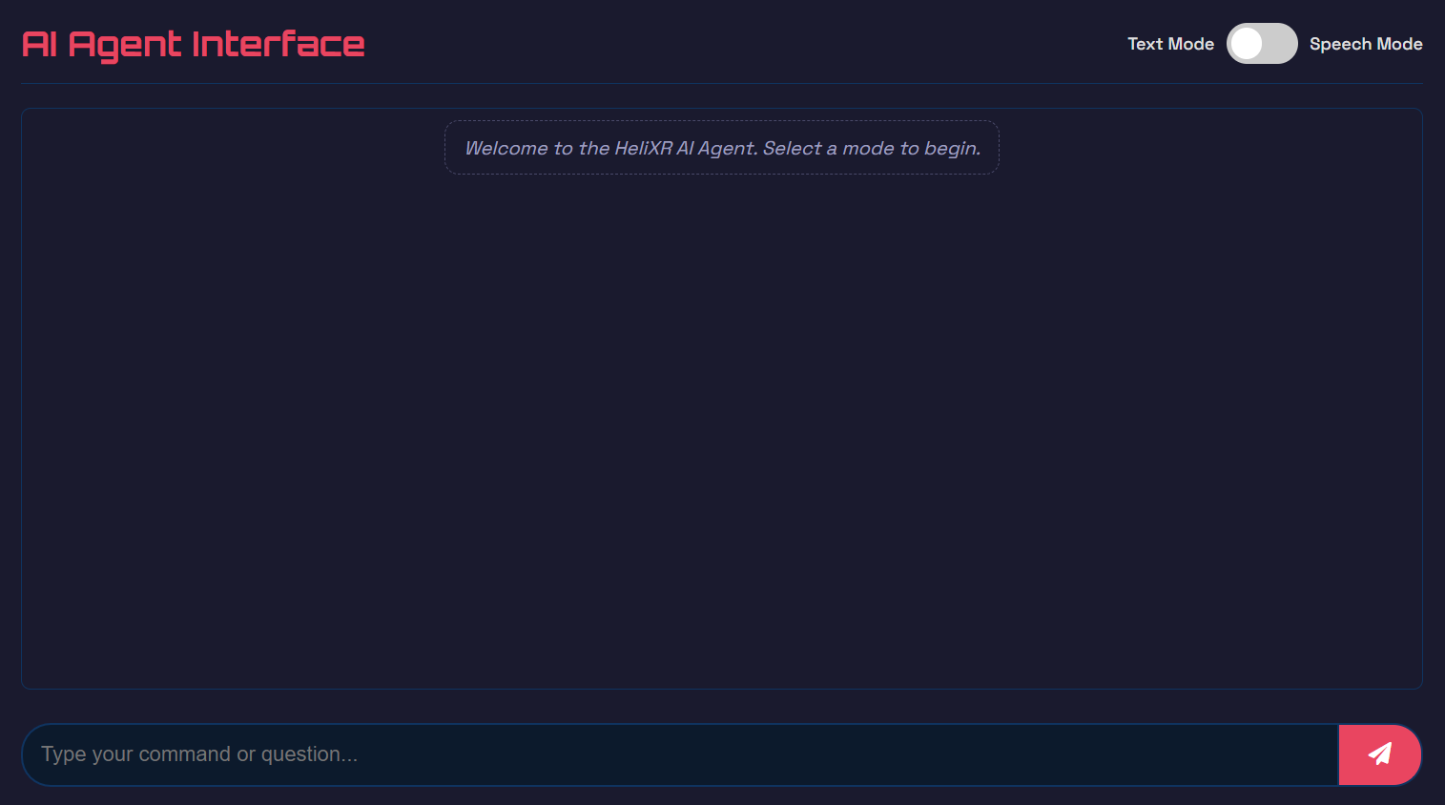

The website front was made user friendly and links to the database for Virtual communications with the model.

All the parameters displayed are real time according to the sensor values from the raspberry pi.

**Efficiency graphs:**

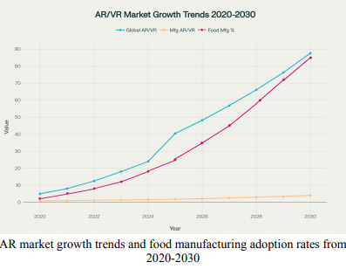

**8.** **Prototype (Hardware/Software)**

### **Prototype Description**

The developed prototype integrates Augmented Reality along with the 3D model to simulate real time changes which the user can perform through the AR app. The same can be done through the AI agent either by text mode or voice mode.

### **Specifications**

1. **3D Printed Facility Model:**
   * Features a high-precision, scaled 3D printed model of the manufacturing facility, designed for seamless integration with AR overlays and live demonstrations.
2. **Real-Time Data Integration:**
   * Connects to IoT sensor networks for continuous, real-time monitoring of parameters such as temperature, humidity, and valve positions, with instant feedback in the AR environment.
3. **Sensors:**
   * **Temperature Sensors:** Monitors heat levels on the PV panel and TEG.
   * **IR Sensor:** Measures the RPM of the rotor which is spinning.
4. **Interactive Control Interface:**
   * Enables users to perform actions like opening/closing valves or adjusting process parameters directly through the AR app’s touch interface or AI agent in the website, with visual confirmation.
5. **AI Agent with Multi-Modal Input:**
   * Includes an AI-powered assistant capable of executing user commands via both text and voice modes.
6. **Website:**
   * Displays real-time system performance, including temperature, pH, humidity
   * AI agent for seamless communication
   * 3D model incorporated in the website.

### **Features and Functionality**

1. **Real-Time Data Monitoring:**
   * Continuously collect and display live data from IoT sensors across all stages of the food manufacturing supply chain, enabling instant detection of anomalies and process deviations.
2. **Remote Valve Control via Touch Interface:**
   * Allow users to manually open or close valves and control other critical equipment through an intuitive touch-based interface on tablets or mobile devices.
3. **Immersive AR/VR Visualization:**
   * Provide interactive, 3D digital twin representations of the manufacturing facility, allowing users to visualize equipment status, process flows, and operational changes in real time.
4. **Data Monitoring via Website:**
   * Displays live data and logs historical performance.
   * Intuitive interface for viewing system parameters and control through commands.

### **Development Process:**

The development process for this AR digital twin and remote control system in food manufacturing follows a structured and iterative approach, beginning with a thorough requirements analysis and stakeholder consultation to identify critical supply chain parameters and user needs. The initial phase involves designing and deploying a robust IoT sensor network across the manufacturing facility to capture real-time data on variables such as temperature, humidity, and equipment status. Simultaneously, a scalable backend infrastructure was created, integrating cloud and edge computing resources to ensure reliable data processing and storage. The next stage focuses on building intuitive user interfaces, including a web platform for monitoring, a mobile app for AR visualization, and seamless integration of a voice assistant capable of executing control commands. Digital twin models of the facility and equipment are developed using 3D modeling tools, ensuring accurate real-time synchronization with live sensor data. Rigorous testing is conducted at each step, including system integration, user acceptance, and security validation, to guarantee performance, safety, and compliance with industry standards. Finally, a 3D printed model is produced for live demonstrations and stakeholder engagement, while ongoing feedback from users informs iterative improvements and feature enhancements throughout the deployment lifecycle.

### **Testing and Validation:**

The testing and validation phase ensures the AR digital twin and remote control system operates reliably and safely in food manufacturing environments. It begins with unit testing of individual components like IoT sensors, valve actuators, AR modules, and the voice assistant to verify functionality. Integration testing follows to confirm seamless data flow and real-time synchronization between devices and interfaces. Performance tests assess system responsiveness and scalability under continuous operation. User acceptance testing involves real-world scenarios to evaluate usability and effectiveness of touch and voice controls. Safety and security validations ensure compliance with industry standards, including fail-safe controls and secure data transmission.

**9.** **Conclusion**

### **Summary**

In conclusion, the proposed AR enhanced digital twin system for food manufacturing offers a transformative solution that integrates real-time monitoring, remote control, and immersive visualization to optimize supply chain operations. By combining IoT sensor networks, intuitive touch and voice interfaces, and advanced AR technologies, the system enhances operational efficiency, safety, and decision-making capabilities. Rigorous development, testing, and validation ensure reliability and compliance with industry standards, while the inclusion of a 3D printed model facilitates stakeholder engagement and practical demonstrations. Overall, this innovative platform stands to significantly improve productivity and quality assurance in food manufacturing, paving the way for smarter, more connected industrial processes.

### **Personal Reflection**

**G.D.Pranav.Lakshminarasimhan:**Working on the Unity app for AR and integrating the Raspberry Pi as a controller gave me invaluable hands-on experience in bridging software and hardware for industrial applications. I learned how to design intuitive AR interfaces in Unity that allow users to interact with and control physical devices in real time, which deepened my understanding of user experience in mixed reality environments. Setting up the Raspberry Pi as a controller challenged me to work with hardware protocols, network communication, and ensure reliable data exchange between the digital twin and the actual manufacturing equipment. This project not only improved my technical proficiency in both AR development and embedded systems but also taught me the importance of robust system integration and troubleshooting in creating seamless, user-friendly solutions for smart manufacturing.

**Aarti Shirvante Pai:**Contributing to this project by preparing 3D models for printing and assisting with the physical assembly gave me practical insight into the intersection of digital design and real-world implementation. I learned how crucial precise modeling and prototyping are for ensuring that digital twin systems can be accurately represented and function as intended in a physical environment, especially in the context of food manufacturing where reliability is key. Drafting the IEEE paper further deepened my understanding of the theoretical frameworks, such as the Digital Twin Cyber-Physical Systems (DT-CPS), and the importance of clear technical communication and documentation. This experience not only enhanced my technical and research skills but also underscored the value of interdisciplinary collaboration in delivering innovative, industry-relevant solutions.

**Sumukha Upadhyaya:**Working on this AR/VR digital twin project for food manufacturing has been a transformative learning experience for me. I gained a deep understanding of how immersive technologies like AR and VR can be integrated with IoT and AI to create powerful remote monitoring and control systems tailored for complex industrial environments. Building features such as real-time data visualization, manual and voice-activated valve control, and automated fault detection pushed me to think critically about user interaction, system reliability, and the importance of seamless communication between physical and virtual components. I also learned about industry standards and the value of interoperability, especially in the context of food manufacturing where precision and safety are paramount. Overall, this project not only strengthened my technical skills in digital twin development but also broadened my perspective on the future of smart manufacturing and the practical impact of advanced technologies on supply chain efficiency and problem-solving.

**Akshay Avinash:**Helping with the website development and coordinating the 3D printing of all parts through my connections in the Astra Robotics Club at RVCE was a highly rewarding experience. I learned how essential a well-designed website is for effectively showcasing complex AR/VR and digital twin projects, making technical details accessible to a broader audience. Assisting with the assembly process also gave me practical exposure to how digital designs translate into functional hardware, highlighting the importance of teamwork and resourcefulness. Leveraging my network to facilitate 3D printing taught me the value of collaboration and the impact of strong professional relationships in accelerating project development and overcoming logistical challenges.

### **Overall Reflection**

Working on this AR/VR digital twin project for food manufacturing has been an eye-opening journey that brought together a wide range of technical and collaborative skills. From developing real-time monitoring and control systems to integrating AR interfaces, 3D modeling, hardware assembly, and building a user-friendly website, I experienced firsthand how multidisciplinary teamwork is essential for innovative solutions. The project deepened my understanding of how digital and physical systems interact, the importance of user experience in industrial applications, and the practical challenges of system integration. Collaborating with friends who specialized in areas like Unity development, embedded systems, 3D printing, and technical documentation showed me the value of leveraging diverse expertise and networks. Overall, this project not only strengthened my technical abilities but also taught me the significance of clear communication, adaptability, and effective teamwork in bringing complex ideas to life.

**10.** **Visuals:**

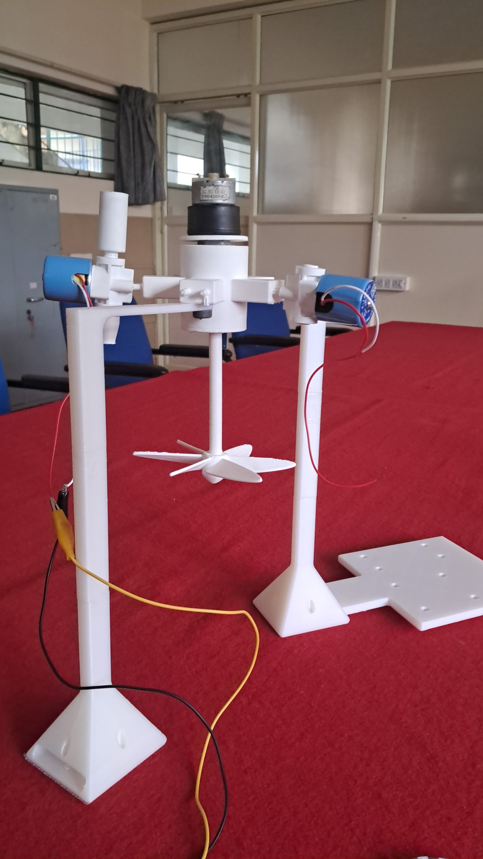

**11. QR Code of Demonstration Video:**

